- Attachment – a resource setting out the range of DR solutions focussed processes
- The following is for illustrative purposes - all rights reserved Angela Lake-Carroll
- Latest Solution-centric graphics
- Resolution options leaflet

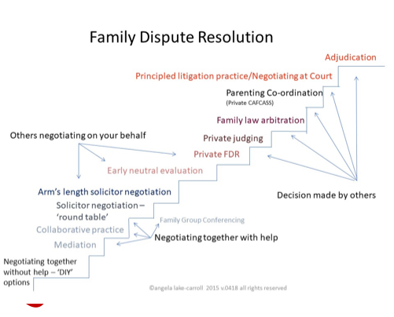

Processes continue to evolve including
Hybrid mediation aka Lawyer Inclusive Mediation – lawyers attending the mediation meetings
Blended mediation, i.e. one participant face-to-face with the mediator and the other remote
The Certainty Project
Therapeutic intervention for challenging children cases that are frequent court returners

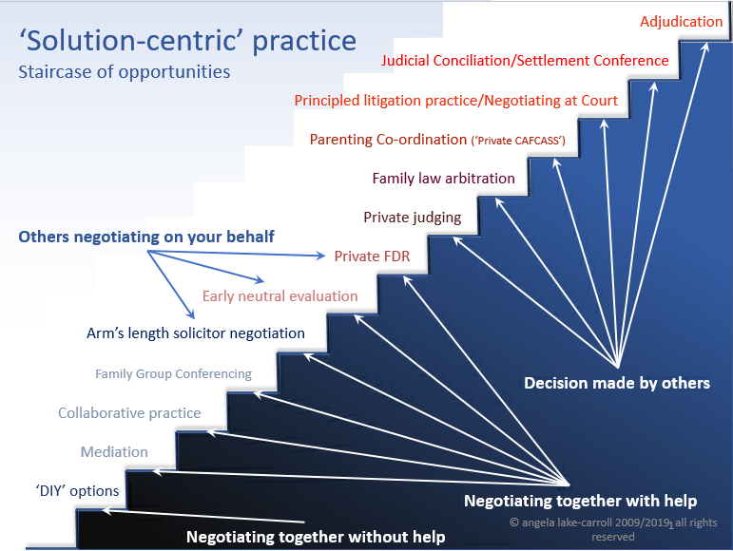
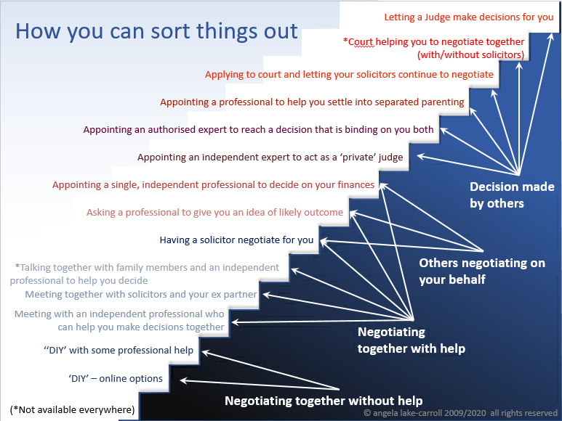

“Something must be done ... We simply cannot go on as we are”
“‘... the time has come when the law-makers in this country, whether they are legislators or judges, must stop saying something must be done and actually do something”
IN FAMILY – we have
- PART 3 Family Procedure Rules
- The Family Procedure (Amendment) Rules 2020, which came into force on 6 April 2020 (save for rules 10 to 14 – the costs rules - which came into force on 6 July 2020)
- A range of sophisticated out-of-court process solutions
IN CIVIL – they have
- Civil Practice Direction – pre-action conduct and protocols – in short parties who litigate without any consideration of ADR do so at their own risk. The courts have shown a remarkable willingness to impose cost sanctions on parties who, in the view of the judge, have unreasonably refused to mediate.
Parties often issue to obtain a court timetable
this may be more suitable for financial rather than children applications, but if the court is being used to ‘chivvy up’ the other party can we not find some robust ‘prod’ / stick that does not take up so much of the court’s time and resource as at present?
PROPOSAL - A streamlined quasi-judicial / administrative process for robust case-management / timetabling with increased (continuing) use of online / virtual hearings and court ordered ADR

The proposed Part 3 Protocol – must be robust, have ‘teeth’, be consistently applied and have a range of unattractive sanctions / consequences including
- the court’s refusal to hear the matter, i.e. stay / adjourn the proceedings for x months
- vocal judicial displeasure / ‘rollocking’, leading to costs orders against both the parties and / or their legal advisers
- negligence and / or disciplinary actions against non-compliant legal advisers

I have had a go at drafting the Protocol

- In accordance with 3.3 (1) [or a new Family Procedure Rule] in all case management reviews [define] and at all hearings the court/judge must undertake the Part 3 Review [define] and certify that they have done so by recording on the court file [contents of record/certificate]

- [At First Appointment the court must

- direct the matter to a non-court dispute resolution process to include the date by which it must be conducted which date can be moved/delayed only by further order of the court or
- certify why it has not so directed]

- [The parties if self-presenting or their] legal advisers must [consider/apply] Part 3 at all times including pre and post issue of court proceedings and evidence [by way of contemporaneous file notes/records] that they have done so

- At each hearing or when called upon by the court to do so it shall be the duty of the legal advisers [parties if self-representing] to provide to the court a copy set of the correspondence and attendance notes emanating from 5 & 6 below (the Part 3 communications).

- [The parties if self-presenting or] legal advisers must issue an open invitation to the other party to engage in a non-court dispute resolution process detailing [how, what, where, when & funding proposal etc] alternatively they must explain why they are not inviting

- Upon receipt of an invitation as at 5 above the recipient must within 14 days reply in open terms setting out their acceptance / refusal / alternative non-court dispute resolution process [ask for a further 7 days to respond if required]

- Legal advisers must certify in the prescribed form that they have contemporaneously forwarded a copy of the correspondence / attendance notes at 5 & 6 above to their client and that they have appraised them of the range of non-court dispute resolution processes available – to include providing a copy of [the stairway of options or some other resource?]

- If the court considers that a non-court dispute resolution process is appropriate and / or that it has been unreasonably refused, or there has been a breach of this Protocol it may

- adjourn the proceedings for up to [ ] months [Ungley orders]
- order compliance of the Part 3 Protocol
- Order a private FDR or ENE
- make a wasted costs order against a party and / or their legal advisers
- [disciplinary proceedings against legal advisers/report for breach of Code etc]

PART 3 FAMILY PROCEDURE RULES – NON-COURT DISPUTE RESOLUTION II THE COURT'S DUTY AND POWERS GENERALLY Scope of this Chapter 3.2 This Chapter contains the court's duty and powers to encourage and facilitate the use of non-court dispute resolution. The court's duty to consider non-court dispute resolution 3.3 (1) The court must consider, at every stage in proceedings, whether non-court dispute resolution is appropriate. (2) In considering whether non-court dispute resolution is appropriate in proceedings which were commenced by a relevant family application, the court must take into account – (a) whether a MIAM took place; (b) whether a valid MIAM exemption was claimed or mediator's exemption was confirmed; and (c) whether the parties attempted mediation or another form of non-court dispute resolution and the outcome of that process. When the court will adjourn proceedings or a hearing in proceedings 3.4 (1) If the court considers that non-court dispute resolution is appropriate, it may direct that the proceedings, or a hearing in the proceedings, be adjourned for such specified period as it considers appropriate – (a) to enable the parties to obtain information and advice about, and consider using, non-court dispute resolution; and (b) where the parties agree, to enable non-court dispute resolution to take place. (2) The court may give directions under this rule on an application or of its own initiative. (3) Where the court directs an adjournment under this rule, it will give directions about the timing and method by which the parties must tell the court if any of the issues in the proceedings have been resolved. (4) If the parties do not tell the court if any of the issues have been resolved as directed under paragraph (3), the court will give such directions as to the management of the case as it considers appropriate. (5) The court or court officer will – (a) record the making of an order under this rule; and (b) arrange for a copy of the order to be served as soon as practicable on the parties. (6) Where the court proposes to exercise its powers of its own initiative, the procedure set out in rule 4.3(2) to (6) applies.
The Family Procedure (Amendment) Rules 2020, which came into force on 6 April 2020 (save for rules 10 to 14 – the costs rules - which came into force on 6 July 2020).
Civil Practice direction – pre-action conduct and protocols - https://www.justice.gov.uk/courts/procedure-rules/civil/rules/pd_pre-action_conduct The relevant sections paras 3, 8, 9, 10 and 11. These provide, in very broad terms, that litigation is to be a last resort and parties should consider whether negotiation or some other form of ADR might enable them to settle their dispute without commencing proceedings. In the event that proceedings are issued, the court can require the parties to provide evidence that ADR has been considered. If a party fails to respond to a request to participate in ADR or unreasonably refuses to do so, then the court can penalise that party in costs.

